Computing in the Early Years- Nursery
Term  Topic | Area of Learning | Concepts
 |  | 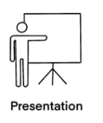  Presentation  Expressing ideas | 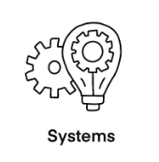  Systems  Knowing how to create and use programmes | 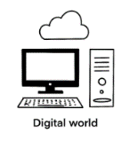  Digital World  Knowing how to use a range of technology
Nursery Autumn 1  Starting School | UW |  |  | -Show an interest in technological toys. Children to learn how to use real objects, such as cameras and touchscreen devices.
Nursery Autumn 2  Night and Day | UW |  |  | -Explore battery operated equipment, learn how to turn something on and off (e.g. torches to create light).  -Identify man-made light sources and why these are necessary.
Nursery Spring 1  Traditional Tales | CL |  | -Show an understanding of prepositions such as under, on top, behind by carrying out an action or selecting the correct picture.
Nursery Spring 2  In the Garden | CL |  | -Use simple directional language such as up, down, left, right, forwards, backwards.
 | L |  | -Develop an interest in letters on a keyboard or other digital media.  -Understand that writing can be typed on screen.
 | UW |  |  | -Record changes in plants over time e.g. buds opening.
Nursery Summer 1  Food and Drink | CL |  |  | -Role-play their experiences of shopping using appropriate language.
 | L |  | -Navigate apps and websites on digital media using a drop-down menu to select websites and icons to select apps. | -Know that information can be retrieved from digital technology.
 | UW |  |  | -Compare and contrast animals first-hand or through videos and photographs.
Nursery Summer 2  Water | CL |  |  | -Look at photographs/ videos of marine life (rockpools) talk about the habitat and learn the names of the animals.
 | UW | -Understand that it is important to take a break from ICT devices or the TV. | -Record what they enjoy doing in nursery, using different ICT equipment (photos on digital cameras, iPads etc). Share this information with their new class teacher/ key person. | -Show an interest in exploring a range of sources such as google Earth, real maps or globes. Locate the South Pole with adult support.  -Create their own maps using real objects, and/or pictures and symbols (e.g., a floor map with markings for cars).  -Discuss the different uses of technology in the school.
 | EAD |  | -Experiment with creating art work using ICT and use the different tools and effects available on the ICT programme to express their ideas.

